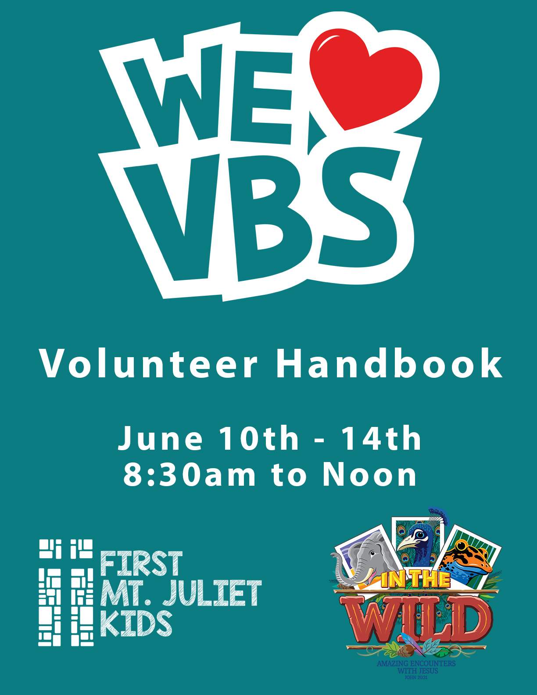

Table of Contents
Purpose 5
VBS Overview Information 6
Registration 6
Decorating Guidelines and Schedule 7
Resources & Supplies 7
Copy & Laminating Requests 8
Clean-up 8
Dress Code Expectations & Cell Phone Usage 9
Volunteer Break Room 9
Children with Special Needs 10
First Aid Clinic 10
Family Night 10
Arrival/Departure & Attendance Information 11
Rotation Themes 13
Daily Bible Themes 14
Daily Dress Theme 14
Mission Theme 15
Rotation Expectations 16
Activity Locations 16
Craft Schedule 17
Snack Schedule 17
Rotation Schedules (Birth-Age 4) 18
Rotation Schedules (PreK and Kindergarten) 19
Rotation Schedules (Elementary 1st-4th Grade) 20
Rotation Schedules (Elementary 5th Grade) 21
Understanding our Participants 22
Leading a Child to Christ 23
Guidelines to Good Discipline 25
Dealing with Disciplinary Problems 26
4~H Leader Safety 27
Emergency Notifications 28
Communication to Teachers during Emergency or Crisis 28
Emergency Agencies Phone Directory 28
Evacuation Procedure 29
Lockdown Procedures 30
Tornado or Natural Disaster Evacuation of Rooms 31
Appendix 33
VBS Classroom Map 35
VBS Supply Request 37
VBS Laminating Form 39
VBS Copy Request Form 41
Background Check Request 43
VBS Adult Volunteer Code of Conduct Agreement 45
VBS Youth Volunteer Code of Conduct Agreement 47
VBS Youth Volunteer Teacher Recommendation 49

Purpose
First Baptist Mt. Juliet Kids Ministry vision is to Connect all kids to Jesus Christ and others. The purpose of this ministry is to partner with parents to mold their children in to the next generation of spiritual leaders. We desire to enlist the cooperation of the entire church to better meet the needs of preschoolers and children while here and away from the church. Lastly, but not least, we want to encourage parents to lead their family to love God, love people and go into the world to make Him known.
VBS is one of the largest evangelical outreaches our church does each year for the children of our community. It is our hope that this document will help inform and equip you as volunteers to be some of the most effective tools during this ministry event. To help us keep track of training and volunteer communication you will find an acknowledgement form at the end of this document. Please sign this form and return it to the Leadership Team at the end of this training. It is our goal to partner with you to make sure this is a powerful ministry striving to impact the lives of all the children in our care.
The VBS Ministry team is a variety of church members who are passionate about this event and feel called to serve making sure this is an outstanding and fun outreach for all who participate. All volunteers 18 years old or older must have completed a background check to ensure the safety and security of each of child in our care. Please fill out online at http://www.fbcmj.org/background-request/

2019 VBS Leadership Team:

Director: | David Love
Registration & Handbook: | Telenia Brooks
Decorations: | Amanda Murray
Crafts, 1st-4th Grade: | Jill Warren
Bible Study Coordinator: | Debbie Rodgers
Birth – 4yr Coordinator: | Tempany Fitzgerald
EK/CK Kindergarten Coordinators: | Amanda Murray & Jodi Skulley
1st – 4th Grade Coordinator: | DeAnn Lee
5th Grade Coordinator: | Melonie Wagner
Worship: | Danielle Puckett
Supplies | RaMona Carter

VBS Overview Information
Our VBS program is for children completed Pre-K through 5th grade. We will also have special classes for babies – 4 year olds for our volunteers’ children ONLY.
We are asking all volunteers to be at the church by 8:00 a.m. It is very important that all VBS volunteers be in their rooms or designated areas by 8:15 a.m. (All volunteers in our Preschool area should be in their rooms and ready by 8:00 a.m.) We want to make sure that we are ready for children the moment the first child arrives. We also know many of you will need to drop off your own children before going to your designated area. Therefore, preschool leaders need to strive for prompt arrival to accept volunteers’ children.
This year’s VBS theme is Lifeway’s In The Wild: Amazing Encounters With Jesus! We will gas up the all-terrain vehicle and head out on a wilderness adventure like no other. Get up close and personal with elephants and egrets, polar bears and penguins, cockatoos and crocodiles, and so much more! Grab a camera and zoom in on these animals in their natural habitats. In The Wild invites kids to focus in on some amazing, real-life encounters with Jesus. Each encounter is like a snapshot – a specific moment in time captured on the pages of Scripture. Are you ready for an up close and personal encounter with Jesus? The adventure of a lifetime awaits!

Registration
It is important for you to make sure to register as a volunteer and register your children. Please encourage any families you know who are planning on attending register on our website. All pre-registered children will be assigned to classrooms. Unregistered, in-coming children will need to check-in at the Registration table to complete a Learner registration card and receive their class assignment. Registration will take place in the Worship Center Lobby where tables will be setup. It is our goal to expedite the registration process, as well as help keep the size of each class uniform. If you are a VBS volunteer, your child/children must be pre-registered by May 13th. You can register on the church website at http://www.fbcmj.org/events

Decorating Guidelines and Schedule
When it comes to decorating our halls and classrooms we want to make sure we do not damage any of the walls or flooring. Plasti-tak or Painters tape may be used in the Children’s Building. ONLY Plasti-tak is to be use on the walls in the Adult building because it does not damage and is easily removed. Please do not put tape or stickers on the floors or walls. If you need to use an alternate tool to hang decorations please make sure you clear its use with one of the Leadership Coordinators before using. Also, please make sure you only use push pins on the bulletin boards provided in the rooms and not on the walls or accordion wall surfaces. It is our goal to make sure that we leave our building in the same condition as we found it.
There are official workdays scheduled prior to the week of VBS. Below you will find that schedule. Please know that even if you are not working in a classroom, we still can use your help and would appreciate you planning on coming and helping out.
This year’s workdays will be:
Monday | June 3rd | 8a – 3p
Tuesday | June 4th | 8a – 3p
Wednesday | June 5th | 8a – 3p
Thursday | June 6th | 8a – 3p
Sunday | June 9th | 12n – 5p
**If you need an alternate time, please contact your Leadership Team Coordinator **

Resources & Supplies
Due to all the varying needs of each Preschool Teacher and Rotation Leaders (Bible Study, Missions, Snacks, Crafts, Recreation, Music) any and all supplies need to be requested. It is important for all Rotation Leaders to please put together your required supply list. It is our goal to provide you the supplies you need but to make sure we are being faithful with our money and resources. Please make sure you are taking this into account when submitting your supply requests. We will not always be able to fulfill everything on your request. If there is something you have requested that we cannot fulfill you will be contacted so that an alternative might be agreed upon.
Please help us each day by returning any items you are done with or did not use to the resource room tables in the hallways. We have volunteers who will put those away so that they can be used another time or another project or activity. Remember we want to be faithful with all the resources provided to us by the church.
Please fill out a Supply Request Form (found in Appendix section of this manual) and submit to RaMona Carter by May 12th in order for materials to arrive by May 26th. Please do not go out and purchase supplies expecting the church to reimburse those funds without speaking to David Love first. It is our goal to make sure we stay within the budget provided.

Copy & Laminating Requests
Any copy or laminating requests must be submitted with the appropriate form (found in Appendix section of this manual) to RaMona Carter by May 12th. Please make sure you fill out the forms completely, include documents to be laminated or copied. Please do not cut out small pieces until after they have been laminated. Documents or materials submitted without the proper form completed will be returned to you. If you have any questions please ask and we will be happy to assist you to make sure all your materials are prepared promptly and efficiently.

Clean-up
Each day it will help the cleaning crew for you to please gather up your trash, tie it up, and put it out in the hallway. Cleanup at the end of VBS will take place on Friday afternoon. Each room will be provided plastic bags for cleanup. There will be a table outside the downstairs resource room of the Children’s building and in the HUB Lobby for returning supplies and used VBS curriculum (which gets donated to other churches to use). Please do not promise any supplies the church purchased to your friends, family, etc. Those arrangements should be made through the Preschool/Children office in order for us not to lose valuable items we planned to keep. Thank you for your help and if you have any questions, please contact David Love.
(It might be a good idea to take a photo of your room before making any changes to décor or set-up. Then use the photo to reset your room before leaving on Friday afternoon.)

Dress Code Expectations & Cell Phone Usage
All attire should be of modest nature and represent FBCMJ well. The children will learn from what is modeled for them by our volunteers at VBS (adult and youth).
The following dress code is the standard of what NOT to wear:
- Very short shorts (athletic shorts), short dresses or miniskirts. Keep in mind that you may be lifting, hauling, getting up and down off the floor and playing games.
- Spaghetti straps, halter tops, or tube tops.
- Leggings are not pants. Shirts should cover below the waist.
- Loose pants or shorts MUST be belted at your waist or just below but not riding down showing underclothes.

If you must look twice and ask, “Is this appropriate?” don’t wear it! Christ is our focus at VBS and not what each other is wearing or not wearing.
- There should be no cell phones. Please put away cell phones and enjoy the kids. (Please reserve cell phone usage for emergencies.)

Volunteer Break Room
There will be a Volunteer break room that will be located in Room LIB 201. This is where various food, drinks and snacks will be available for all volunteers. Volunteers are encouraged to bring their favorite dish or snack items, and beverages to help supplement the choices offered in this area. Please remember NO PEANUTS – we are a Peanut Free Campus!!! We have children with severe peanut allergies. We don’t want you to accidently transfer peanuts to a child from something you ate from the break room.
 | Food | Drinks
Monday | Leadership Team | 5th Grade Team; Pastors
Tuesday | 2yr and 3yr | Recreation; Crafts
Wednesday | 4yr; Pre-K; Kindergarten | Youth
Thursday | 1st & 2nd Grade | Snacks; Music
Friday | 3rd & 4th Grade | Babies; Crawlers; Toddlers

** Tour Guide breaks are scheduled this year.
- 4y – Kindergarten Tour Guides will take their break during Snack Rotation.
- 1st - 4th Grade Tour Guides: Youth will take their break during Craft Rotation. Adult Guides will take their break during Snack Rotation.
Please remember that this room is not there for volunteers to socialize for long periods of time during the day. Our priority should be on the children we are ministering to and this room is provided to say thank you. Any volunteers abusing this room and neglecting their responsibilities should be directed to a member of the VBS Leadership Team.

Children with Special Needs
This year at VBS we are blessed to have an option for children with special needs. Lee Ann Smith will be on standby to help with any child that registers that needs more specialized attention. We hope to learn these details during registration and will communicate the need of the child with the leaders of the rotations for that child’s group. LeeAnn will help oversee that the child is okay and if needed, help provide a buddy from her team of volunteers. However, if you are not made aware of the need of the child and we see there may be an issue during the day, please make contact with LeeAnn and/or David Love. We will work with the volunteers and parents to create the best environment for the child. But if we see the child being in the class is not working for the best of everyone, a class called Breakaway Bay, located in Room 124 in the Children’s Building is ready to meet their needs. Our plan is to first assimilate if possible and if not, have an alternate class for them. The class will not rotate, but the children will still get the privilege of learning and doing as all participants. This class will only be offered for children who have completed PreK-5th grade.

First Aid Clinic
There will be a Medical station available for any first aid or medical issues in MJCA Teacher Breakroom located just outside of the Worship Center. Whitney Wharton will be our Medical Nurse for the week. Please report any serious injuries to Whitney and make sure an accident report has been completed and signed by David Love. A copy of this report will go to David Love and one copy will be given to the parent at the end of the day. We have numerous children with various health issues and allergies. If you have any questions or concerns please speak to Whitney and allow her to assist you, making sure we provide a safe and fun experience for all children.

Family Night
Family night will be Thursday evening, June 13th from 6-8PM. The goal of family night is to encourage all participants to come back that evening for fun and an opportunity for our church to meet and reach out to those un-churched.
We are asking all our adult Bible Study groups to create and man a carnival type game for the event. The classes will have a great opportunity to fellowship with church members but also un-churched people. The classes are encouraged to use the game time to meet those in line and invite them back to FBC and even offer to meet them to come enjoy Bible Study together.
We will start the night off in the worship center at 6:00PM for an opening rally time that will include music, missions recap, slide show of pictures and more. Following the rally, children will head outside for games, popcorn, water, and fun till 8:00PM. If it rains, all games will move into the gym but will not be canceled.

Arrival/Departure & Attendance Information
DropOff / Pick-up
- Birth – Age 4: drop off & pick-up in their respective classrooms in Children's Wing
- PreK & Kindergarten: drop off & pick-up in Children’s Wing, Room A211 (Multi-purpose room upstairs)
- 1st – 5th Grade: drop off & pick-up in the Worship Center

Each Tour Guide will be provided a Daily attendance log, Sign in/out sheet, and a Class roster. These will be placed on a clipboard in your assigned area for Worship Rally. (Birth – Age 4 children clipboards will be in each classroom.)
- The Attendance log is what each Tour Guide will use to let us know who is participating each day. It is also an easy way for you to communicate with the Leadership Team to let us know if there are any questions, concerns or issues you need our help with. Please make sure you complete your class attendance sheet first thing each morning and drop them in your assigned locations, as follows:
  - Birth – Age 4: Team Coordinator, Tempany will collect from each room at 9am and deliver to Registration Coordinator.
  - Pre-K & Kindergarten: Please deliver to Team Coordinators, Jodi Skulley or Amanda Murray upon leaving the Worship Rally. They will deliver to Registration Coordinator.
  - 1st-5th Grade: Please drop in the box located outside on Registration Table immediately following the Worship Rally.
- The Sign In/Out Sheet is used to document drop off and pickup. Please check off children names as they arrive during drop off. Parents/Guardians are required to sign the child out for the day. This provides our security for the child’s release. We are liable for the safety and protection of these children and we will make sure they are always returned to the appropriate Parent/Adult. Please DO NOT ever leave children unattended until they are in the comfort of a parent or guardian’s presence. Please leave these on your clipboards and they will be collected by your Team Coordinator at the end of the day when clipboards are updated.
- The Class Roster will be for you to keep on your clipboard with you throughout the day. If there is an emergency and we need to evacuate the building, you have a record of all the children that are under your care each day. We want to make sure that we keep track of all children at all times. Please see the Crisis Plan later in this handbook regarding emergency procedures.

- Name Tags will be given to all children PreK–5th Grade on Monday. Tags will contain their Name and any Allergy information. They should wear these at all times and throughout the week. Tour Guides will collect all name tags immediately following the Closing Rally so they are available the next day during the Worship Rally. PreK-Kindergarten Tour Guides will keep tags at their group’s location in A211. 1st-5th Grade Tour Guides will collect and place in their group’s assigned pew in the Worship Center.

Bus Rider attendees will be given a wristband to wear for the day. This will assist us at the end of the day during dismissal. An announcement will be made during the Closing Rally for those children to follow a Leader to the designated bus pick up area.
Wristband | Dismissal Area
Blue Checkerboard | North Entrance
Orange Checkerboard | North Entrance
American Flag | North Entrance

Rotation Themes
Opening Worship Rally & Closing Rally
This is our opening and closing worship time. We will gather each day to worship together, hear the theme for the day, watch daily teaching videos and pray God’s blessings over our day.

Bible Study
This is the time each day when we will dig into God’s Word. We will help kids experience God’s words and His truth in a unique way using the Bible and a real life situation.

Recreation
In Recreation, we will play games to get some energy out and have some fun.

Snacks
In Snack time, we will create an interactive snack and eat together before moving to the next station. While snacking, we will see our Missions emphasis in a simple video of a missionary and His family.

Craftivity
Is it a craft or is it an activity? Both! This is the time when we will create craftivities. Each day’s craft will help bring the Bible story and/or theme to life visually.

Music
This is the time to teach the kids the music. This is such a valuable tool to help them hide God’s Word in their hearts and reinforce the lessons they have learned all week. It is proven that music and motions can help you to remember what’s learned for life.

Daily Bible Themes
Each day has a different bible story within the In The Wild! theme. All stories, activities, crafts and snacks will go along with each day’s story.
- Memory Verse: “But these are written so that you may believe that Jesus is the Messiah, the Son of God, and that by believing you may have life in his name.” John 20:31

- Christ Connection: The Bible tells us what is true about God and about ourselves. Jesus is the Messiah, the Son of God. When we trust in Jesus as Savior and Lord, He forgives us our sin and gives us eternal life.

- Motto: Gear Up! Get Ready! Game On!

DAY | BIBLE STORY | DAILY POINT
Monday | Encounter in the Temple  (Luke 2: 41-52) | Jesus talked about God. (PreK-K)  Jesus knew why He came. (Grades 1-5)
Tuesday | Encounter at the River  (Matthew 3:1-17) | Jesus is God’s Son. (PreK-K)  Jesus is the Son of God. (Grades 1-5)
Wednesday | Encounter on the Water  (Matthew 14:22-33) | Jesus can do anything. (PreK-K)  Jesus proved He is God’s Son (Grades 1-5)
Thursday | Encounter at the Tomb  (John 20: 1-18) | Jesus is alive! (PreK-K)  Jesus rose from the dead. (Grades 1-5)
Friday | Encounter on the Road  (Luke 24: 13-35) | All of the Bible tells about Jesus. (PreK-K)  The Bible was written so I can believe. (Grades 1-5)

Daily Dress Theme
Day | Dress Theme
Monday | FBCMJ or VBS t-shirt Day
Tuesday | Neon Day- Wear your favorite neon colored attire
Wednesday | Wacky Tacky Day- Wear as many colors as possible
Thursday | VBS t-shirt- can be current or former VBS t-shirts  (will have Group Photos for family night)
Friday | Group Favorite – Each Tour Group should select a ‘favorite’ theme for the day – could be favorite color, sports theme, character, etc.

Mission Theme
Missions will be a focus of our opening rally for our Pre-K & Kindergarten groups and during closing rally for our 1st-5th grade groups. During the 2019 Snack rotations, children will view a video to learn about Jorge Santiago, a missionary in Comerio, Puerto Rico, and the Harrell Family in Mozambique, Africa. Both Missionary families have chosen to go on a wild journey that involves some unusual ways of having real encounters sharing about Jesus with others!
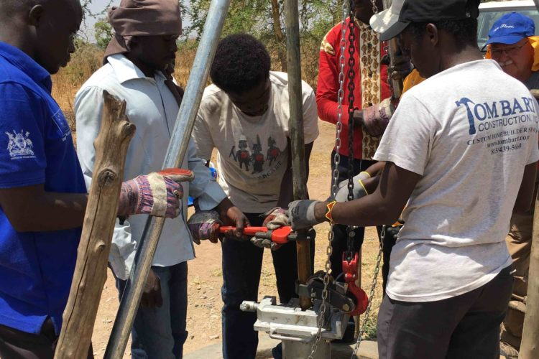This year we are partnering with the Baptist Global Response to help show the love of Christ to families and villages in need. The offering money that you bring will go to drill wells, install hand pumps and train pump care committees in nine villages, bringing clean water to over 22,500 people, many of whom have no other clean water source. Previous well-drilling projects have seen lives rescued in times of serious drought. Communities have risen together to better care for one another and their neighbors through the presence of well-maintained and governed water pumps. Communities will also learn about good stewardship through the committees that oversee the pumps.
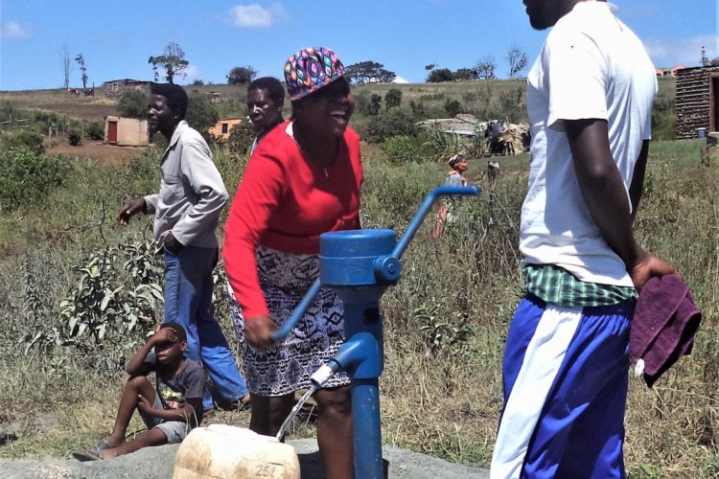

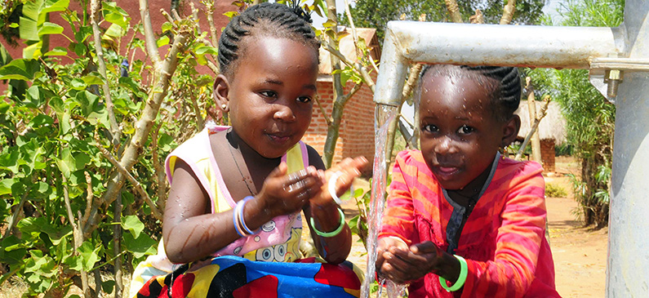

Rotation Expectations
There are several expectations concerning the rotation format which will ensure that each child gets the most out of each day. These expectations will help keep each location within the schedule organized and on task throughout the morning. Please familiarize yourself with them and know you are the key to the rotation schedule working effectively.
- Be on time for each rotation
- Tour Guides MUST stay with their group in each rotation location. (Exception: Tour Guide breaks are scheduled this year.)
  - 4y – Kindergarten Tour Guides will take their break during Snack Rotation.
  - 1st - 4th Grade Tour Guides: Youth will take their break during Craft Rotation. Adult Guides will take their break during Snack Rotation.
- All Rotation Leaders should be prepared upon arrival of each group of children to lead their rotations. (ie. Bible Study, Recreation, Crafts, Snacks, Music)
- Count your tourists before leaving each location. NO CHILD IS TO BE LEFT UNACCOMPANIED AT ANY TIME!!!
- Leave the location on time to ensure the next session begins as scheduled.

Activity Locations
** Pre-K through 5th Grade Children will begin and end their day in their Worship Rally location.
Activity | Location
 | PreK & Kindergarten | 1st - 4th Grades
Worship Rally | Multi-Purpose A211 | Worship Center
Crafts | A203 & A204 | Rm 1, HS 102 | Rm 2, HS 103
Snacks | A210 | Fellowship Hall
Bible Study | A in A201  B in A202 | Red, HS 106  Blue, HS 107 | Yellow, HS 100  Green, HS 101
Music | Multi-Purpose A211 | Worship Center
Recreation | Outside, weather permitting | Gym
Closing Rally | Multi-Purpose A211 | Worship Center

Craft Schedule
Day | Preschool Crafts (A131)
Monday | Church
Tuesday | Jesus Water Bottle
Wednesday | Tshirt
Thursday | Joy Stick
Friday | Safari Hat

Day | 4Yr PreK – 4th Grade Crafts
 | Kindergarten  (A203& A204)  4yr, Pre-K, Kindergarten | Children  (HS 102 & HS 103)  1^{st -} 4th Grades
Monday | Butterfly | I Spy Jesus
Tuesday | Snake and Chameleon | Sticks and Stones Travel Game
Wednesday | Animal Mask | Stormy Sea Rain Stick
Thursday | Stained Glass Cross | At the Tomb Story Tiles
Friday | Bird | ‘In The Wild’ Journal

Snack Schedule
Day | Preschool - Kindergarten Snacks
 | Crawler – 3s  (In Room) | 4y Pre-K - Kindergarten  (A210)
Monday | Stick Giraffe
Tuesday | Twizzler Cross
Wednesday | Bear Snack
Thursday | Donut Tomb
Friday | Animal Feed / Snack Mix

Day | Elementary Snacks
 | 1^{st -} 4th Grades (Fellowship Hall)
Monday | Stick Giraffe
Tuesday | Twizzler Cross
Wednesday | Bear Snack
Thursday | Donut Tomb
Friday | Animal Feed / Snack Mix

Rotation Schedules (Birth-Age 4)
Babies /Ones #110 (Yellow) |  |  |  | 4 Year Room # 114 (Brown)
8:00-8:15 | Arrival & Sign In |  |  | 8:00-8:15 | Arrival & Sign In
8:15-8:40 | Games & Music |  |  | 8:15-8:35 | Games w/ Art & Activity
8:45-9:10 | Buggy Ride |  |  | 8:40-11:55 | Rotating Upstairs as PreK-1 grp
9:15-9:40 | Craft Time (#A131) |  |  | 12:00-12:15 | Quiet Time / Movie
9:45-10:00 | Snack |  |  | 12:10-12:30 | Dismissal & Sign Out
10:00-10:10 | Bible Story
10:15-10:40 | Rec Time (#A111 or A130)
10:45-11:10 | Buggy Ride
11:15-11:45 | Free Time
11:45-12:15 | Quiet Time / Movie
12:15-12:30 | Dismissal & Sign Out

2 year Room #112 (Mushroom): |  |  |  | 2 year Room #119 (Teal):
8:00-8:15 | Arrival & Sign In |  |  | 8:00-8:15 | Arrival & Sign In
8:15-8:40 | Bible Story |  |  | 8:15-8:45 | Games & Music
8:45-9:10 | Rec Time (playground) |  |  | 8:45-9:10 | Bible Story w/ Art & Activity
9:15-9:40 | Buggy Ride |  |  | 9:15-9:40 | Rec Time (#A111 or A130)
9:45-10:00 | Music |  |  | 9:45-10:00 | Mission & Music
10:00-10:20 | Crafts |  |  | 10:00-10:15 | Snack
10:20-10:40 | Snack |  |  | 10:15-10:40 | Buggy Ride
10:45-11:10 | Rec Time |  |  | 10:45-11:10 | Free Time
11:15-11:40 | Buggy Ride |  |  | 11:15-11:40 | Craft Time (#131)
11:45-12:15 | Quiet Time / Movie |  |  | 11:45-12:15 | Quiet Time / Movie
12:15-12:30 | Dismissal & Sign Out |  |  | 12:15-12:30 | Dismissal & Sign Out

3 year Room #115 (Purple): |  |  |  |  | 3 year Room #118 (Blue):
8:00-8:15 | Arrival & Sign In |  |  |  | 8:00-8:15 | Arrival & Sign In
8:15-8:40 | Rec Time (playground) |  |  |  | 8:15-8:40 | Bible Story w/ Art & Activity
8:45-9:10 | Bible Story |  |  |  | 8:45-9:10 | Rec Time (#ADM 212)
9:15-9:45 | Games |  |  |  | 9:15-9:45 | Games & Music
9:45-10:00 | Craft Time (#131) |  |  |  | 9:45-10:00 | Snack
10:00-10:25 | Music |  |  |  | 10:05-10:20 | Mission & Music
10:30-10:45 | Snack |  |  |  | 10:20-10:35 | Free Time
10:45-11:05 | Free Time |  |  |  | 10:40-11:05 | Craft Time (#A131)
11:10-11:40 | Rec Time |  |  |  | 11:10-11:40 | Rec Time (playground)
11:45-12:15 | Quiet Time / Movie |  |  |  | 11:45-12:15 | Quiet Time / Movie
12:15-12:30 | Dismissal & Sign Out |  |  |  | 12:15-12:30 | Dismissal & Sign Out

Rotation Schedules (PreK and Kindergarten)
* Important to make sure we start the day with first rotation on time.
Pre-Kindergarten
Class | 1 & 2 | 3 & 4 | 5 & 6 | 7 & 8
8:30-9:05 | Worship Rally
9:10-9:35 | Music | Music | Rec | Rec
9:40-10:05 | Rec | Rec | Snacks | Snacks
10:10-10:35 | Snack | Snack | Bible A | Bible B
10:40-11:05 | Bible A | Bible B | Craft A | Craft B
11:10-11:35 | Craft A | Craft B | Music | Music
11:40-12:00 | Closing Rally

Completed Kindergarten
Class | 9 & 10 | 11 & 12 | 13 & 14 | 15 & 16
8:30-9:05 | Worship Rally
9:10-9:35 | Bible A | Bible B | Craft A | Craft B
9:40-10:05 | Craft A | Craft B | Music | Music
10:10-10:35 | Music | Music | Rec | Rec
10:40-11:05 | Rec | Rec | Snack | Snack
11:10-11:35 | Snack | Snack | Bible A | Bible B
11:40-12:00 | Closing Rally

Overall Areas At-A-Glance (Pre-K and Kindergarten):
Area / Time | 9:10 | 9:40 | 10:10 | 10:40 | 11:10 | Location
Bible Study A | 9 & 10 | OFF | 5 & 6 | 1 & 2 | 13 & 14 | A201
Bible Study B | 11 & 12 | OFF | 7 & 8 | 3 & 4 | 15 & 16 | A202
Music | 1-4 | 13-16 | 9-12 | OFF | 5-8 | A217
Craft A | 13 & 14 | 9 & 10 | OFF | 5 & 6 | 1 & 2 | A203
Craft B | 15 & 16 | 11 & 12 | OFF | 7 & 8 | 3 & 4 | A204
Rec | 5-8 | 1-4 | 13-16 | 9-10 | OFF | MP A211
Snacks | OFF | 5-8 | 1-4 | 13-16 | 9-12 | A210

Rotation Schedules (Elementary 1st-4th Grade)

First Grade
Class | A | B | C | D
8:30-9:00 | Worship Rally
9:05-9:30 | Rec | Rec | Rec | Rec
9:35-10:00 | Bible Red | Bible Blue | Craft 1 | Craft 1
10:05-10:30 | Craft 1 | Craft 1 | Bible Red | Bible Blue
10:35-11:00 | Snack | Snack | Snack | Snack
11:05-11:30 | Music | Music | Music | Music
11:35-12:00 | Closing Rally

Second Grade
Class | A | B | C | D
8:30-9:00 | Worship Rally
9:05-9:30 | Snack | Snack | Snack | Snack
9:35-10:00 | Music | Music | Music | Music
10:05-10:30 | Rec | Rec | Rec | Rec
10:35-11:00 | Bible Red | Bible Blue | Craft 2 | Craft 1
11:05-11:30 | Craft 1 | Craft 1 | Bible Red | Bible Blue
11:35-12:00 | Closing Rally

Third Grade
Class | A | B | C | D
8:30-9:00 | Worship Rally
9:05-9:30 | Music | Music | Music | Music
9:35-10:00 | Rec | Rec | Rec | Rec
10:05-10:30 | Snack | Snack | Snack | Snack
10:35-11:00 | Bible Green | Bible Yellow | Craft 2 | Craft 2
11:05-11:30 | Craft 2 | Craft 2 | Bible Yellow | Bible Green
11:35-12:00 | Closing Rally

Fourth Grade
Class | A | B | C
8:30-9:00 | Worship Rally
9:05-9:30 | Craft 2 | Craft 2 | Bible Green
9:35-10:00 | Snack | Snack | Snack
10:05-10:30 | Bible Green | Bible Yellow | Craft 2
10:35-11:00 | Music | Music | Music
11:05-11:30 | Rec | Rec | Rec
11:35-12:00 | Closing Rally

Overall Areas At-A-Glance (Elementary 1st – 4th Grades):
Area / Time | 9:05 | 9:35 | 10:05 | 10:35 | 11:05 | Location
Bible Blue - Grades 1&2 | OFF | 1B | 1D | 2B | 2D | HS 107
Bible Red – Grades 1&2 | OFF | 1A | 1C | 2A | 2C | HS 106
Bible Yellow - Grades 3&4 | OFF | OFF | 4B | 3B | 3C | HS 100
Bible Green - Grades 3&4 | 4C | OFF | 4A | 3A | 3D | HS 101
Craft 1 | OFF | 1C & 1D | 1A & 1B | 2C & 2D | 2A & 2B | HS 102
Craft 2 | 4A & 4B | OFF | 4C | 3C & 3D | 3A & 3B | HS 103
Music | Grade 3 | Grade 2 | OFF | Grade 4 | Grade 1 | WC
Snack | Grade 2 | Grade 4 | Grade 3 | Grade 1 | OFF | FH
Recreation | Grade 1 | Grade 3 | Grade 2 | OFF | Grade 4 | Gym

Rotation Schedules (Elementary 5th Grade)

 | Area
8:30-9:00 | Worship Rally
9:05-11:00 | Youth Area (for Bible Study, Missions, Snack, Excite, Explore, Excel)
11:35-12:00 | Closing Rally

Fifth graders will enjoy VBS geared just for them by our youth ministry staff in the youth area. They will have an amazing time with more age-appropriate snacks, crafts, and in-depth Bible Study.

Understanding our Participants
VBS is one of the largest community outreaches that FBC Mt Juliet Kids does each year. Our churches focus is to LOVE GOD, LOVE PEOPLE and GO INTO THE WORLD. It is our opportunity to bring hundreds of children into our church for the opportunity to love on them and share Jesus with them for an entire week. We will have four kinds of children and adults participate.
The first kind of participant is the faithful church attender. These children come to church all the time. They know about the building; they know the teachers; they know many of the Bible stories. Some will attend because they want to, others because they have a parent volunteering and they know this program is designed to meet the needs of these children. As they move to various areas, they will participate in fun, challenging, and different methods of learning Bible stories, memory verses, crafts, missions and music.
The second kind of participant is the occasional attender. These are children who come to church sometimes but not on a regular basis. We know their faces and they may think they know their way around. Actually these are the children who tend to get left without a clue. These children need extra attention and encouragement to get them "plugged in" on a regular basis. Our goal is to build strong relationships with these children and their parents. They may be our best prospects.
The third kind of participant is the child from another church. During the summer, every town or city has a group of "roving" children. They attend church somewhere else, but they like to go to everybody's summer programming. These children may come from a wide variety of churches and have different understandings about the Bible and its message. Welcome these children and trust God to help you be sensitive to these differences as you teach them.
The last kind of participant is the child who has never been to church. These children need a church with unconditional love. They are not going to be familiar with anything. They may not have heard any of the Bible stories we will tell and will not be familiar with the Bible. This is an opportunity to catch their attention and help them think, "Hey I love this church stuff!" They need to know that the volunteers they are interacting with exemplify Jesus Christ in all they say and do. They need positive, caring relationships with people who love them and show them God loves them. We need to use this week to begin building a foundation with these children and parents hoping for further opportunities to minister to them.

For whatever reason, the Lord has brought them to us
and for that we will rejoice and love them!

Leading a Child to Christ
This year at VBS, the gospel plan of salvation will be presented during the Bible Rotation on Thursday. It will be done as a group with an opportunity to respond in quiet and for those who respond, they will be counseled by Bible Counselors. David will then follow up with each child individually.
Talking to a child about becoming a Christian brings fear to the hearts of many. Will they understand what we’re talking about? If they make a decision, how will I know if it’s real? What if I say something wrong? While these concerns are valid, we need to trust the work of the Holy Spirit and remember we do not save anyone, He does.
Another thing to remember is there is only one way to heaven. There is not one way for adults, another for youth and another for children. The Bible tells us that Jesus is the only way to heaven and anyone who believes in Him will have eternal life (see John 14:6 and John 3:16).
If an opportunity arises for you to discuss salvation with a child, there are a few simple tips to remember.
Share with children individually. Talking with a child one to one gives you insight to what they are thinking and feeling. Often times with a group, children will answer for each other. Talking with one child at a time shows each child that the decision they are making is personal and important enough for individual attention.
Use open-ended questions. These are questions requiring more than a yes or no answer. Children want to please and by asking a question only needing a yes or no, they will give the answer they believe will please those asking the question. Use questions that have the child put what they believe into words. Here are some examples: Who is Jesus? What is sin? Why is sin a big deal? What makes someone a Christian? Why do you want to become a Christian?
Encourage a child to express his own ideas and allow time for thinking and responding. It is not unusual for a child to take up to a minute or even longer to answer a question they have not had to think about previously. Give the child time to respond and avoid answering for him. If some time has passed and you sense the child is struggling to put his thoughts into words, reword your question and see if that helps.
Avoid using symbolism or church talk. For those raised in church being conscious of word choice is important. What does a child think when we talk about being lost? For many an instant of being separated from mom or dad comes to mind. What about saved? Thoughts of being rescued from a swimming pool may pop into his head. If you are not sure if a child understands a word you are using, define the word as you are talking or ask him if he can tell you what it means. Avoid giving more information than a child asks for or needs. A lot of spiritual conversations, especially between parents and children, come from questions asked by children. These questions often arise after they witness something spiritual (such as baptism or the Lord’s Supper) or after a tragic event (an accident or loss of a pet). When a child asks a question, answer the question simply. See if the child has any more questions based on your answer and let the child guide the conversation. It is easy to get excited when a child asks a spiritual question and want to tell them everything about becoming a Christian at once. If the child gets bombarded with information that is beyond what they are asking, they lose interest. It may also keep them from coming to you in the future with questions if they are afraid they may not understand your answer or if it will lead to a really long conversation.
Use the Bible. Tracts and tools are wonderful, but if at all possible use a Bible as well when sharing with children. This shows them the truths being shared come from God’s word and gives them the chance to know where to find them later if needed. If a child has a Bible with him, use it and mark the verses you refer to.
If an opportunity arises, pray and talk with the child. Please make sure the Beth Howe is aware so the family can be notified and the child receives further discipling. Salvation is the biggest decision a child will make in their life.
Here is a simple example of how to counsel a child:
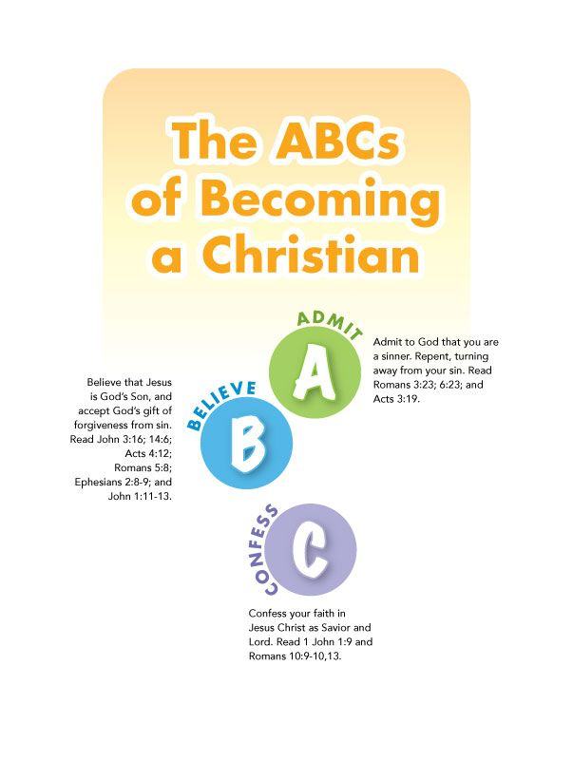

Guidelines to Good Discipline
The word “Discipline” originally came from the Latin word “disiplina” which means teaching or learning. Therefore, the original intention for discipline was to train or develop. Below you will find the guidelines we have put in place when it comes to discipline during VBS. The old cliché says that an ounce of prevention is worth a pound of cure. It is true!
So how can you help prevent discipline problems? When you use preventive discipline, it means that you take action long before a problem has a chance to occur. We want to create a loving, caring atmosphere. The classrooms need to be arranged in an environment for children to explore their different learning styles. It will help you to prepare your teaching materials prayerfully and thoroughly, this way you can make sure you have activities for the entire time the children are in your care. Give the children clear instructions and ample warning when it is time to move to the next activity. One of your best tools will be to have something for the children to do at all times. In order to gain respect you must grant respect. This can be done by establishing and communicating realistic and attainable expectations. As you focus on positive actions, strive to remain fair and consistent then you will begin to develop a strong relationship and an environment where the children feel safe and loved. Lastly, be aware of children with special needs. It is important to get to know your parents and when there is a problem, partner with them to discover the best method to get the child involved in the class in the most positive and effective manner.
When you are talking to children whether for discipline issues or problem solving it is best to get onto their level (sit or kneel). Look them in the eyes because it shows respect. As you talk with them observe their behavior and talk to them, strive to listen with your ears, eyes and heart. What they say is not always what they mean. Make sure to not interrupt them and then repeat what the child has said so you both understand what is being communicated. That will allow you to work together to resolve the problem/issue.
Most of all know that the Leadership Team is here to partner with you to make this an exciting week of evangelism and relationship building. If you are struggling with a child please let us know so we can help you. It is hard to provide a quality environment if you are frustrated, so when you reach this point seek out your Team Representative and we will help you resolve the issue.
Remember Our Goal is … Relationships!
A relationship requires communication.
Communication requires more than us talking:
It requires LISTENING.
This class is for the children!
No program or activity is more important than us
meeting other people’s needs.
*To know their needs, we must LISTEN!

Dealing with Disciplinary Problems

The key to good discipline is to remember that a disciplinary situation is an opportunity to love a child. Here are the steps to consider when it comes to disciplinary problems.

If possible learn why there is a problem whether is it physical, which may be discomfort, fatigue, or hunger. It may be mental or developmental, which is when a child wants attention, feels compared to other students, or feels a need for self-expression. In every situation ask for God’s help with the solution of every problem. When we seek discernment, He is faithful to help us know the best way to help each child. We need to show Christian love; remember the age of the child and his ability to handle certain situations. Make sure you are always trying to be consistent, fair and keep your word. It is important to model appropriate behavior and strive to act sympathetically and with grace. When you see good behavior make sure you praise and celebrate those victories.

Working as a team is important. One effective tool is to have another teacher “distract” the child from the misbehavior, by talking with the child about the activity the group is presently involved in; and if necessary by moving the child to another activity and getting him/her involved. Please use “Time-out” as a last resort. We want to show these children respect so take them out of the room for discipline. Disciplining a child in front of others is embarrassing. Also, some children want to misbehave and be reprimanded in front of others for attention. “Time out” can be used for repeated misbehavior. Do not give up. God knows this child. God loves this child. He is using you to show this child His love. This can and often takes time and patience.

If you have given the child a verbal warning, then moved the child to another area within your classroom, placed the child in time-out by removing him/her from the room and the behavior continues – contact a Leadership Team member. He/She will do his/her best to get the child back in the right spirit and return them to your class or call the parent.

Please, please make sure you never use sarcasm as a weapon. Children are very literal and do not understand sarcasm. Do not assume that a child who is as motionless as a vegetable is a good child, because his mind may be at the circus. It is easy to make the mistake those wigglers and gigglers are getting nothing from the lesson. The mind of a child is often a mystery.

Most of all do not give up! It takes time and patience to overcome
any problems in child discipline.

4~H Leader Safety
Not only is safety and security our number one value for our children, but it is for our leaders and staff as well! Here are a few guidelines to ensure safety for our children and leaders while providing ways for our leaders to show affection to our children without compromising their integrity:

Hug- Hugging a child is a natural response when children seek affection.

  - If a child runs to a leader for a hug, the “catch and release” method is preferred. Quickly give a hug and release from the hug gently.
  - Side hugs are most appropriate. Instead of a body to body front hug, a side to side hug will not be misunderstood and be just as effective.

High five- High fives are a great way to show encouragement to a child and a fellow leader.

  - It is a great expression to say, “Way to go!”
  - Children as young as 12 months can learn how to high five.

Handshake- Handshaking is a friendly way to greet someone, especially for the first time.

  - A handshake with the right hand and cupped with the left is a more personable greeting.
  - Any child older than second grade should politely be discouraged from holding their leader’s hand. A child who is just learning to walk and toddling around may need the help of their leader’s hand for stability. This is perfectly acceptable. A child as old as second grade may desire to hold the hand of their leader. We would ask that it be a female adult leader only.

Hold- Some children seek to be held by a leader as a form of security or affection.

  - A child over the age of two years should not be held unless it is an emergency for their transport. Piggy back rides are not permitted.
  - There is a difference between holding an infant under the age of two years and hugging an older child. Infants will need more attention. If holding a baby is necessary for their comfort and safety, we require the leader to be an adult of 18 years and older.
  - If a child seeks sitting on the lap of the leader, we ask the leader to gently place the child directly next to them and away from their lap.

Emergency Notifications
Lockdown | Intercom announcement
Evacuation | Intercom announcement
Tornado Drill | 3 long bells
Fire Drill | Siren and Strobe lights
All clear | Intercom announcement

- Rotation Leaders should make themselves aware of evacuation procedures from their classroom/activity location. They are main contact for leading Tour Guides and children in their area during an actual emergency.

Communication to Teachers during Emergency or Crisis
In the event of an emergency or crisis, leadership team will communicate via radios and a message will be announced over the intercom systems in both buildings. Please listen for the indicated emergency below and follow the proper procedure to ensure the safety or our kids and adults.

Emergency Agencies Phone Directory

Child Protection Agency (DCS) | 1-877-237-0004
Poison Control Center | (615) 936-2034
MJ Police Department | 911 or (615) 754-2550
MJ Fire Department | 911
MJ Ambulance Service | 911

Evacuation Procedure
The following procedures are for evacuating the building in the event of fire, explosion, or other severe building emergencies.

- Evacuation routes/procedures are posted in each room; make sure you are familiar with the route assigned to your room.
- All children, personnel, and visitors exit the building using designated exit routes. Children are to quickly exit the building, in an orderly manner, without talking.
- Tour Guides are responsible for evacuating children in their classrooms, and are accountable for them throughout the duration of the evacuation period.
- Unless there is an intercom over-ride, everyone (including all members and visitors) must begin evacuation when the fire alarm sounds. Those not in the direct care of children may provide a supportive role in the hallway checking doors, restrooms, etc., and may monitor progress, but must also move to evacuate. An ‘all call’ to confirm a false alarm will be handled by administration personnel, only in the event that safety concerns are eliminated.
- Classroom doors and windows are to be closed as students exit. Lights need to be turned off. Teachers are to bring their class roll with them in order to account for all children in your classroom. All exits should be unlocked.
- Administrative and office staffs are assigned designated areas to inspect to be sure the building has been completely evacuated.
- Children line up in designated areas of the parking lot or ball field, a safe distance from the building.
- Tour Guides take roll for the children under their supervision. In the case of a missing child, the Staff MUST be notified.
- When the “all clear” signal is given, children and teachers may return to the building. They are to return in an orderly manner without talking.

Lockdown Procedures

A Church Lock Down may be appropriate to include but not limited to the following:
- Trespass violation with threat
- Out of control parent
- Domestic violence
- Medical emergencies
- Acts of violence
- Hostage situation
- Suicide or threat
- Law enforcement chase or man-hunt in area of the church

Tour Guides will:
- Upon hearing or receiving the lock down message, LOCK DOWN, each adult should immediately move into a classroom and bring every child, and/or parents in the immediate area and keep them with you (even though they may not be assigned to you). Then close and LOCK YOUR DOOR. Prepare to exit the building if necessary.
- Immediately take rolls and add any extra people you have collected. Also mark any children that are missing or absent.
- Remain calm. Alert your children that there may be a situation or concern. It is extremely important that you remain in control of your class. Have your children move to a location where they cannot be seen through the door, crouch on the floor and under no circumstances release a child into the hallway.
- Children on the playgrounds should seek shelter and safety by selecting a spot to hide. Tour Guides should keep the class together, and follow authorities’ instructions. If children and tour guides can get safely to Rutland Place or to West Wilson Middle School, they should proceed.
- Give a copy of your class roll, with any additions or notes about missing children, to David Love or police upon request.
- When given the direction by police or administrator, move your class from the building in a controlled, quiet manner to the area designated. BE SURE YOU CARRY YOUR CLASS ROLL AND THE NAMES THAT YOU MAY HAVE WRITTEN DOWN.
- Listen carefully to all instructions given during the situation; we will try to tell you the location of the troubled area in any announcement so that measures can be taken to avoid that area.
- Children may not go to the bathroom or enter the hallway for any reason.
- Do not return to the building until permission has been given.
- Do not give statements to anyone or give the media access to your children. All information will be provided by the Pastor or Children’s Director.

Tornado or Natural Disaster Evacuation of Rooms
- Eastside Preschool Rooms: Proceed to hallway, assume position, and remain there until the “All Clear” signal is given.
- Westside Preschool Rooms: Enter bathroom, assume position, and remain there until the “All Clear” signal is given.
- PreK & Kinder Rooms (2nd floor Children’s Building): Proceed downstairs to Eastside hallway, Eastside stair well, or Mother’s Room - assume position and remain there until the “All Clear” signal is given.
- LIB classrooms: Downstairs to the hallway
- Student Classrooms: Proceed to hallway
- Gym Floor: Proceed to weightlifting hallway
- Walking Track: Proceed to downstairs hallway

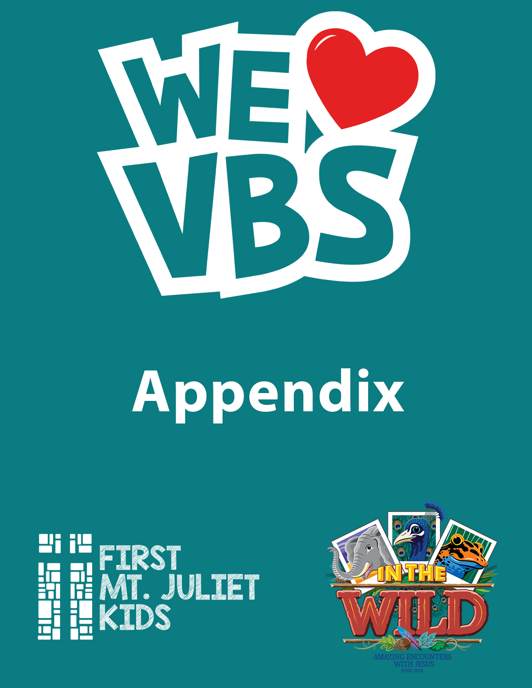

VBS Classroom Map

Date of Request _____________________Room __________________________
Person Requesting __________________________________________________
Phone ___________________ Email ____________________________________
PLEASE USE AS MANY AS NECESSARY
Please draw room, identifying doors, windows, dividers, etc., so that we may understand north, south, east, & west. Please specify the furniture you would like to have moved out.
(Keep in mind we have limited storage space, but if you ask not, then you get not!)

Please take a photo of your room before making any changes to décor or set-up. Then use the photo to reset your room before leaving on Friday afternoon. Resetting is your responsibility.

VBS Supply Request

Date of Request _____________________Room __________________________
Person Requesting __________________________________________________
Phone ___________________ Email ____________________________________
Please complete and return this request by May 12th so that it can be filled by May 26th. If we are unable to fill your supply request or have questions concerning the same you will be notified. Please be aware of your classroom time and only request what you will use.
Supply | Quantity | Request Filled  (Do Not Write in Gray Area)

VBS Laminating Form

Date of Request _____________________Room __________________________
Person Requesting __________________________________________________
Phone ___________________ Email ____________________________________
Please complete and return your request by May 12th so it can be filled by May 26th. If we are unable to process your request or have any questions concerning them you will be notified.

List all items to be Laminated and attach to request

VBS Copy Request Form

Date of Request _____________________Room __________________________
Person Requesting __________________________________________________
Phone ___________________ Email ____________________________________
Please complete and return your request by May 12th so it can be filled by May 26th. If we are unable to complete you request or have any questions regarding them you will be notified. Please attach all items to be copied.
NN  # of Copies | Description of Original | Instructions (Type of paper, etc)

Background Check Request
All Adults over the age of 18 who are serving during VBS are required to complete a background check.

Please fill out the following required information. Please print clearly. (or access online via http://www.fbcmj.org/background-request/)
First Name:
Last Name:
Social Security Number:
Date of Birth:
Gender:
Driver’s License Number:
Driver’s License State:
Email
Street Address:
City:
State:
Zip:
Signature:

VBS Adult Volunteer Code of Conduct Agreement
Upon signing this agreement, I agree to the following statements after receiving the VBS handbook and adequate training to fulfill my purpose as a FBCMJ VBS volunteer.
I agree to be a good role model to children and to set an example for the visiting families that emulate what God would expect of me.
I agree to follow the handbook guidelines regarding safety, child protection and propriety. If I have any questions, they will be asked prior to VBS.
I understand that this volunteer experience is a gift that I give to my church and the community. Therefore I also understand this is a mission outreach project and not a place just to see friends. I will not focus my energies on socializing but instead focus on giving children a really great experience that they might never have had before.
Because negative, unproductive or uncooperative behavior occasionally surfaces, everyone needs to be aware of the RULES and understand we serve Christ first.
- Arrive on time and ready for the day
- This is not a social party. If the kids are ignored and not cared for, the volunteer will be spoken to by a VBS Leadership Team member.
- I will use language that reflects a Christian attitude. I will not use curse words or other foul language.

- I will deal peacefully with anger and disagreements.
- Absolutely no foreign substances of any kind allowed on the premises (drugs and alcohol)
- There should be no cell phones. Please put away cell phones and enjoy the kids.
Respectful behavior from all is expected at all times. If these rules are not followed the person in question will be spoken to by a VBS Leadership Team Member and/David Love. Depending on the severity of the circumstance, one may be asked to leave for the remainder of the day and/or asked to leave for the rest of the week.
I understand these rules and will follow them.
Print Name ____________________________________________________
Signature ____________________________________________________ Date ____________________

VBS Youth Volunteer Code of Conduct Agreement
Check each circle before signing to show you agree and will adhere to each statement.
- I will respect myself, other people, other people’s property, and the church property.
- I will be an encourager, not one who ridicules, makes fun of, or criticizes.
- I will deal peacefully with anger and disagreements.
- I will participate and contribute in a positive way in all group activities and obey the instructions of the VBS staff.
- I will be an example to the younger children and show respect by participating, encouraging them to participate and not causing disruptions.
- I will use language that reflects a Christian attitude. I will not use curse words or other foul language.
- I will wear modest clothing. No very short shorts (athletic shorts), short dresses or miniskirts. Keep in mind that you will be lifting, hauling, getting up and down off the floor, and bending over. No spaghetti straps, halter or tube tops. Leggings are NOT pants. Shirts should cover below the waist. Loose pants or shorts MUST be belted at your waist or just below but not riding down showing underclothes.
- I will not use cell phones, iPods, or other personal electronic or entertainment devices during VBS.
- I will stay with my group or in my assigned area at all times except during my break. I will know how many children are in my group and where they are at all times.
- I will check-in and check-out on time each day. Arrive at least 15 minutes prior to Worship Rally Starting.
- I will not pass out any candy or food unless it is provided from VBS. I will not eat any candy or food or drinks in front of the children that they are not also having.
- I will not pick up or carry any children without adult permission.
- Only youth who have completed online registration and have been approved may attend and volunteer at VBS. All Youth Registration MUST be completed by May 6th. NO YOUTH will be allowed to just show up the day of VBS to volunteer to complete any community service hours. Youth Volunteers MUST be a member of FBCMJ, MJCA Students, and or associated by family membership. NO EXCEPTIONS!
~How are you affiliate with FBCMJ or MJCA? _____________________________________________________________________
~You need to submit a teacher recommendation__________________________________________________________________
I have read the Youth Volunteer Code of Conduct and the youth handbook and agree to abide by these guidelines or encourage and ensure that my child abides by these guidelines. Any violations, will result in being sent home and no community service hours will be approved.
Medical and Photo Release
* Photo Release: We do not publish any names of kids/students with photos. Use of photos is limited to FBCMJ website, VBS video, Children’s Ministry FB page, Twitter and other church media. Any other use of photos would require additional parental consent.
Medical Release: I/We the undersigned have legal custody of the child named above, a minor, and have given our consent for him/her to attend events being organized by First Baptist Church Mt. Juliet. If child experiences a medical situation, every effort will be made to contact the legal guardians first. In the event the legal guardians are not available and the child needs medical attention, this consent form gives permission to seek whatever medical attention is deemed necessary, and releases the Church and its staff of any liability against personal losses of named child. We understand that there are inherent risks involved in any ministry or athletic event, and I/we hereby release the Church, its ministers, employees, agents, and volunteer workers from any and all loss, or damage to person or property that may occur during the course of my/our child’s involvement. In the event that he/she is injured and requires the attention of a doctor, I/we consent to any reasonable medical treatment as deemed necessary by a licensed physician. In the event treatment is required from a physician and /or hospital personnel designated by the Church, I/we agree to hold such person free and harmless of any claims, demands, or suites for damages arising from the giving of such consent. I/We also acknowledge that we will be ultimately responsible for the cost of any medical care should the cost of that medical care not be reimbursed by the health insurance provider.
______________________________________ ______________ __________________
Student Signature Date Cell #

______________________________________ ______________ __________________
Parent/Guardian Signature Date Cell #

______________________________________ ____________________________________________
Parent/Guardian Name~ Printed Parent Email

VBS Youth Volunteer Teacher Recommendation

I can confidently recommend ____________________________________ to serve with kids during VBS for First Baptist
(Students Name)
Mt. Juliet. This student shows a great attitude and outgoing personality and would be a great fit to serve kids during VBS.

Teacher Name: _______________________________________________________________________
Teacher Email: _______________________________________________________________________

Additional Comments: ________________________________________________________________________________________________________________________________________________________________________________________________________________________________________________________________________________________________________________________________________________________________________________________________________________________________________________________________________

